**[feedback](javascript:return%20false;)**

< div id="noscript-padding"></div>< div id="noscript-warning">Our site works best with JavaScript enabled, please consider turning it on...</div>

Top of Form



Bottom of Form

**Deck Information**

Name: Sample Deck for James Ellis

Description: Sample Deck for James Ellis

Date Created: 7/7/2012 8:55:20 PM (local time)

**Why are we here?**

* To better track and report on tire inventory
* Better financial reporting
* Better sales tracking
* Better store performance tracking
* Move away from manual tracking to electronic tracking
* An easily expandable system

**What is your elevator pitch?**

* Northwestern's New Inventory System - This new system will automate the currently manual processes of updating and keeping track of the tire inventory including the sales, on hand inventory, order history, and individual store information. - Is Approved? False

**What does your product box look like?**

* Back - Simplified Inventory Management
* Front - Real-time Inventory Tracking
* Front - Sales Tracking
* Left - Multiple Store Management

**Whats on your NOT list?**

* Not In Scope
  + Outside Vendor Access
  + Payroll Data
* Unresolved
* In Scope
  + Inventory Management
  + Sales Tracking
  + Wholesale/Retail Pricing
  + Sales Reporting
  + Inventory Reporting

**Who are your neighbors?**

* Person - Jill - Bookkeeper
* Person - Andrew Scholder - Project Contact
* Person - Al Rankin - Owner
* Person - Frank - Warehouse Manager
* Group - Store Managers - Inventory/Sales Tracking
* Group - Sales People - Sales People
* Group - Employees who will make transfers/inventory/lookup - Users
* Group - Rincon Consulting - Software Developer

**What does the solution look like?**

Technical Architecture - Technical Architecture

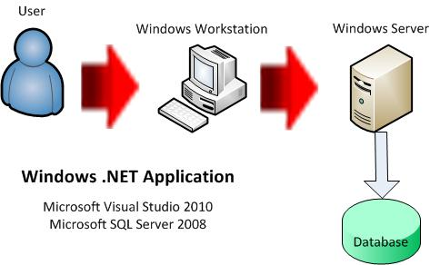

**What keeps you up at night?**

* No co-located team members
* Availability of Andrew for project consultation
* Size of development team
* Employee ramp up time
* Short project window
* Feature creep

**How big is it?**

* Launch
  + should begin on 7/7/2012 and end on: 7/21/2012.
  + Description: Project Kick-off and Design Meetings.
  + Estimated Duration: 14 days.
* Build
  + should begin on 7/15/2012 and end on: 7/29/2012.
  + Description: Create database, create forms, and code..
  + Estimated Duration: 14 days.
* Train-Test-Handoff
  + should begin on 8/4/2012 and end on: 8/18/2012.
  + Description: Train users, test product, handoff to Northwestern Tires..
  + Estimated Duration: 14 days.

**What are the trade-offs?**

*This is the scale that is used for* ***Core Success Factors***

1. Very Fixed
2. Somewhat Fixed
3. We Could Go Either Way
4. Somewhat Flexible
5. Very Flexible

Here are the values that you entered for your **Core Success Factors**

* Scope - 2
* Team Size - 1
* Budget - 5
* Time - 1
* Quality - 4

*This is the scale that is used for* ***Other Success Factors***

1. Very Unimportant
2. Somewhat Unimportant
3. Undecided
4. Somewhat Important
5. Very Important

Here are the values that you entered for your **Other Success Factors**

* Ease of Use - 5
* Simple Design - 5
* Flexible / Extensible Design - 3
* Security - 1
* Scalability - 2
* Performance - 3
* Multitenancy - 1
* Service Oriented Architecture - 1
* Uses Cloud Resources - 1
* Is a Composite / Mashup - 1

**What will it take?**

**Scenario 1**

Estimated Cost: **$0**

This scenario assumes the following:

* team size of ***4 people***
* has a project duration of ***6 weeks***
* an average hourly rate of ***$0***